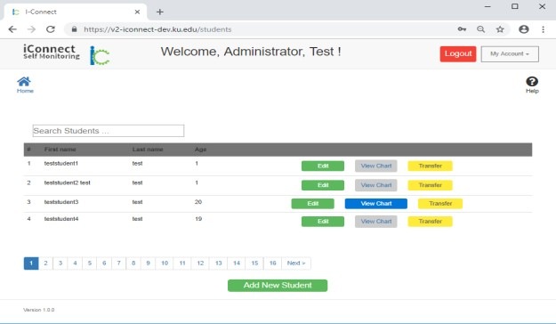

- Login to Website
The Welcome Page
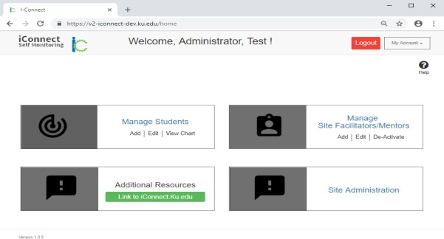
From the welcome page Site- Facilitators, Mentors, and Students can be managed and their progress tracked

  - Select Manage Students
- Manage Students Page
Add a New Student
Accounts for students you manage are listed with options to Edit students, View Charts, and transfer them to different Mentors.

  - Select Add New Student
- Add New Student Identifiers/Demographics
Add/Edit Student Page (Step 1)

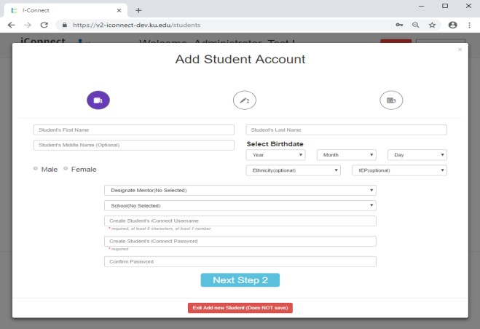
Enter Student Name, Birthday, Gender, Possession of IEP, designate a Mentor, and establish a User Name and Password.
  - Enter student information then select Next Step 2
- Add New Student Categories, Locations, Goals
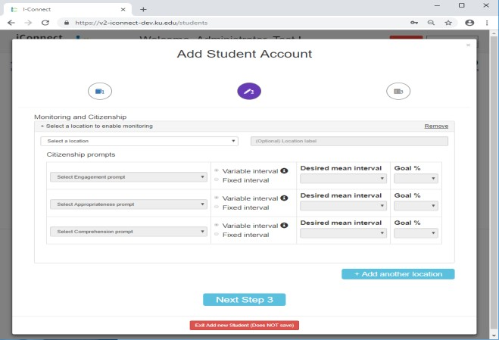
Add/Edit Student Page (Step 2)
Enter locations in Student’s Home, Community, School, and Work. Specify prompts and intervals for each location that will be monitored.
  - Enter student information, then select Next Step 3
- Finish Adding New Student
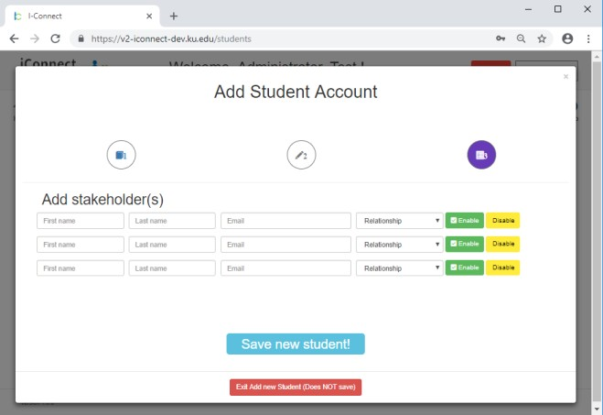
Add/Edit Student Page (Step 3)
Enter appropriate Stakeholders (i.e. student’s guardians) who should be allowed access to viewing student’s data.
  - Add stakeholders, then select Save new student!
- Manage Students Page

Add/Edit Student Page
The Add/Edit Student Page appears with the newly added student.

