I-Connect is a powerful intervention that helps students to stay on task, complete assignments and improve their academic accuracy. It can be incorporated into a school or district practices in various ways. Some districts or schools may choose to implement I-Connect as a district-wide initiative, while others may choose to use I-Connect with a specific population of students or as a teacher resource. Below are some examples of how I-Connect can support students:

MTSS Tier 2 Team
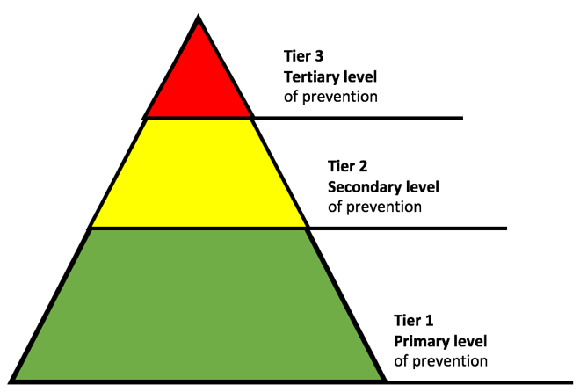 | I-Connect is an ideal Tier 2 intervention, it provides specialized support to students with a flexible timeline and instant data collection.
The MTSS Tier 2 team identifies 1-2 team members to lead the implementation of I-Connect onto the team. These leaders would complete the readiness assessment, act as site facilitators to organize and support mentors (teachers and paraprofessionals who will be using I-Connect).

Once I-Connect is in place the MTSS Tier 2 uses the charts exported from the I-Connect app to make data driven decisions for students.
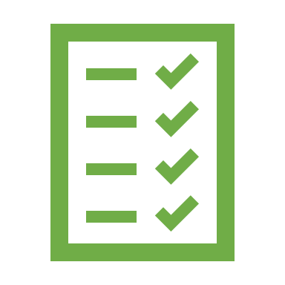 | I-Connect implementation guide includes all the necessary resources to incorporate I-Connect into the roster of practices: training videos, fidelity checklists, nomination form, and alignment guide.  The site facilitators would support mentors in problem solving and monitoring use of the I-Connect to ensure fidelity is maintained.

ASD Support Team

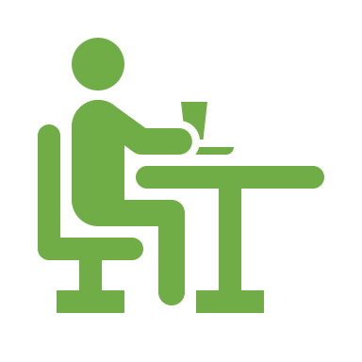 | Students with ASD often struggle with staying on-task and refraining from engaging in disruptive and distracting behaviors in class. These behaviors can impact their academic performance and time spent in the general education classroom.
 | ASD support teams can choose to include I-Connect as an intervention for students with ASD, the team would complete the readiness assessment and provide individual training to teachers and staff to use the intervention. With the guidance of the ASD Support Team, the classroom teacher or paraprofessional would meet with the student to introduce I-Connect and incorporate it into current behavior programs.
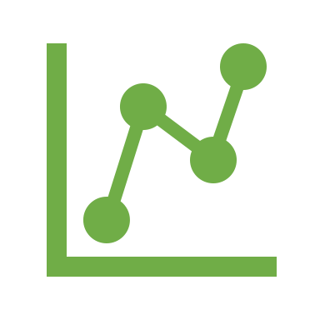 | Weekly meetings with the student to review progress would encourage the student to meet established goals, and access reinforcements.  The ASD Support team would act as a site facilitator and meet regularly to review the charts exported from the I-Connect app and make data driven decisions to continue or adjust the intervention to ensure fidelity is maintained.

Special Education Department

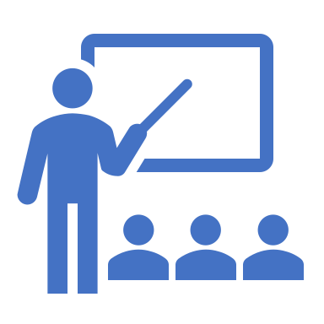 | A Special Education department or team may choose to use I-Connect as a support for students who struggle to stay focused. A team leader would complete the readiness assessment and provide an overview of I-Connect to special education faculty and staff.
 | Special education teachers and paraprofessionals would register as mentors and begin using I-Connect with students. IEP Teams would use the charts exported from the I-Connect app to make data driven decisions for students.
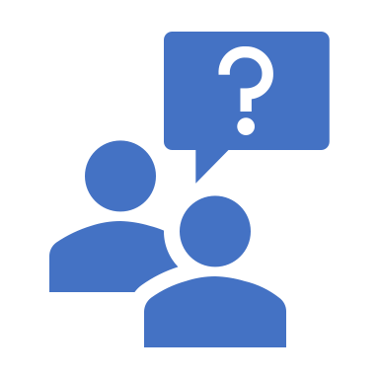 | The special education team leader would register as a site facilitator to support mentors in problem solving and monitoring use of I-Connect to ensure fidelity is maintained.

Grade-level Team

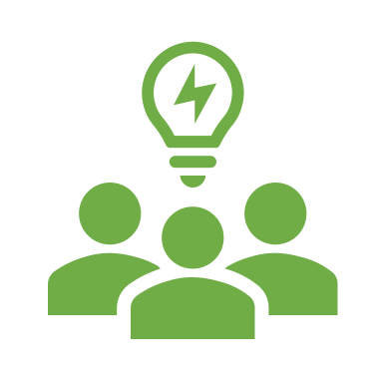 | A grade-level team may choose to introduce I-Connect as a support for select students across the grade who are struggling to stay on-task. The team would complete the readiness assessment and the training videos to become mentors for their homeroom students.
 | Students would use I-Connect across classrooms and meet individually with mentors during homeroom to review charts of their progress and celebrate successes.
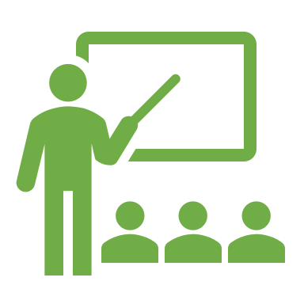 | As students learn how to self-monitor, they complete more academic work with less disruptions, and the teachers have more time to provide instruction.

