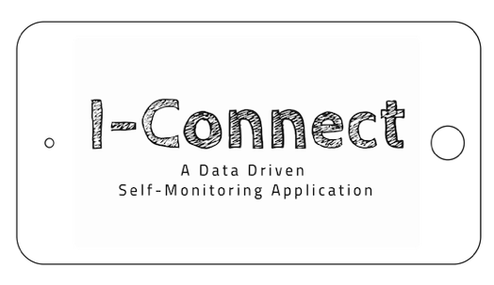
in the Classroom
Troubleshooting

I-Connect works best for students:
- Who are likely to daydream or “zone out” during class.
- Who need frequently reminders to complete the assigned work.
- Who engage in disruptive or distracting behaviors.
- Who engage in non-aggressive or destructive impulsive behaviors.
- Who are able to learn a multi-step sequence.
- Who are able to read written language.
- Who are able to make momentary shifts in their attention between tasks.

Student does not want to use I-Connect because they don’t want to look different. | - Use I-Connect with multiple students  - Introduce desktop app first, then move to mobile app once student has success  - Consider adding reward/reinforcement when student meets goal.
Student does not want to use I-Connect because they are tired of being watched | - Review the purpose of I-Connect is for the student to be in charge of their behavior, when using it appropriately the student will experience less redirections and corrections.
Parent is worried about additional screen time. | - Assure parents students will be interacting with the screen for less than 5 seconds, each time a prompt is delivered.
Student is not accurate when they rate themselves | - Increase proximity to student when prompt occurs, to ensure student records response accurately.  - Practice assessing behavior using examples/non-examples during mentor meetings.  - Consider adding reward/reinforcement when student meets goal with accurate recordings.
Student is distracted by technology | - I-Connect only runs when the app is open on the screen, if the student navigates away the timer will stop.
Other students are distracted by technology | - Provide a preliminary reminder to student about respectful use of technology and differentiated supports
Student is recording accurately, but performance is not improving (i.e. still off task or disruptive) | - Adjust prompt to be more meaningful to student.  - Adjust interval to issue prompt before disruption or distraction is likely to occur.

